Wavebaseball.com creates Newsletter

Welcome to the 1st edition of the Wavebaseball.com newsletter. For the past 3 years, Wavebaseball.com has brought you the latest information and pictures of the Tulane University Baseball team. The newsletter will be an addition to the website. The idea is to create a print version that people can be delivered to people via email, or the Postal Service.
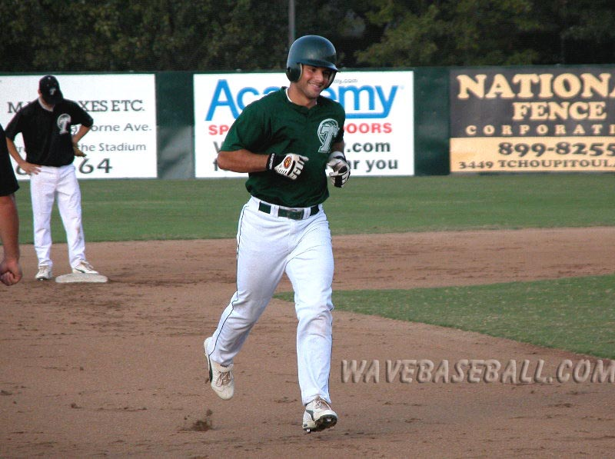
The first issues of the newsletter will be free, via email. Printed editions can be purchase, but the pricing has yet to be determined. Here is some information you might want to know.

How often will the newsletter be published?
Team Captain – Brian Bormaster

It will be a seasonal publication, but will have “special editions” outside of the College Baseball season. Right now, the intent is to publish the 1st newsletter on the Monday before the Alumni game, and every Monday after, until the season ends. Additional “special edition” newsletters will be published during the summer, and then fall season. The summer edition will have information on where the guys are playing summer ball, and the fall edition(s) will have information about Fall Ball practices.

What kind of information will be in the newsletter?

I plan to do interviews, pictures, and of course, a summary of the previous week’s games. I will then do a preview of the up-coming games. I envision that the newsletter will average 2 or 3 pages, with at least 1 page dedicated to pictures from the previous week’s games.

Is this an official Tulane publication?

No, I must stress that this is not an official Tulane publication. It is written by a fan, for the fans, and for people that want to know more about the Tulane Baseball team.

Why should I pay for a printed newsletter, if it’s free online?

You don’t have to pay to view the newsletter. In keeping with the tradition of the origins of the Web, I want to keep everything on-line free. The charge is only for those people that want a printed copy that requires postage.

Tulane Alumni Game Preview

The annual Tulane alumni game will be on February 7, 2004. Official Tulane release:

Click here for the Official Tulane Release

Old-Timers Game: 12:00 Noon

Up first will be the Old-Timers game. As described to me, it will involve players that have not been played any professional baseball the last 5 years. It should prove to a fun event.

Alumni Game: 2:00 PM

The 2004 Alumni game will feature the starting lineup from the 2001 CWS team. This could prove to be one of the toughest games all year for Tulane, as players like Jake Gautreau, James Jurries, and Michael Aubrey will be playing for the Alumni.

Previous Tulane Coaches Featured:

3 previous Tulane coaches will be at the festivities, and will be introduced. Coaches Ben Abadie, Milton Retif, and Joe Brockhoff guided Tulane Baseball for a total of 29 years.

1979 & 1994 Teams to be honored.

Two teams will be honored on Saturday, February 7. The 1979 team featuring Joe Brockhoff, the 1st Tulane Baseball team to appear in the NCAA Tournament.

The 1994 team is Coach Jones’ 1st team that he managed at Tulane, and that team also earned a NCAA Tournament birth.

Fan Day / Autograph Session.

Stick around after the game, as all the participants will sign autographs for all of the Fans. This is the 1st time this has been done, but should be a smashing success, as previous fan days at Turchin have always been a fan favorite.

UPCOMING IN THE NEXT ISSUE

The next issue will have highlights of the Old-Timers and Alumni Games, and have a preview of the upcoming Season, as well as, the UT-Arlington series. Publication Date will be Monday, February 9, 2004.

Have you donated to TAF?

504 – 865 – 5356

This is not a paid advertisement. I decided to ask you to donate to TAF, especially in light of the New Turchin Stadium. Without TAF, and the funds that are raised through TAF, the New Turchin Stadium would still be a pipe dream. So, donate now, electronic forms are available at the Tulane Website –

Click here for the TAF home page

NEW! Charge a small monthly amount to your credit card. If you have always wanted to become a TAF member, but didn’t have a large lump sum of money, now you can charge as little as $10.50 a month. Hit the link

Click here for TAF monthly Billing

